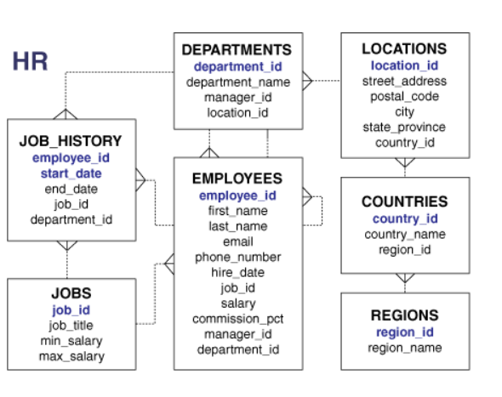

**1.** From the following table return complete information about the employees.

**2.** From the following table, write a query to find the salaries of all employees. Return salary.

**3.** From the following table, write a query to find the unique designations of the employees. Return job name.

**4.** From the following table, write a query to list the employees’ names, increase their salary by 15%, and express the number of Dollars.

**5.** From the following table, write a query to list the employee's name and job name as a format of "Employee & Job".

**6.** Write a query to produce the output of employees as follows.

**7.** From the following table, write a query to find those employees with a hire date in the format like February 22, 1991. Return employee ID, employee name, **8.** From the following table, write a query to count the number of characters except the spaces for each employee name. Return employee name length.

**9.** From the following table, write a query to find the employee ID, salary, and commission of all the employees.

**10.** From the following table, write a query to find the unique department with jobs. Return department ID, Job name.

**11.** From the following table, write a query to find those employees who do not belong to the department 2001. Return complete information about the

**12.** From the following table, write a query to find those employees who joined before 1991. Return complete information about the employees.

**13.** From the following table, write a query to calculate the average salary of employees who work as analysts. Return average salary.

**14.** From the following table, write a query to find the details of the employee ‘BLAZE’.

**15.** From the following table, write a query to identify employees whose commissions exceed their salaries. Return complete information about the employees.

**16.** From the following table, write a query to identify those employees whose salaries exceed 3000 after receiving a 25% salary increase. Return complete information about the employees.

**17.** From the following table, write a query to find the names of the employees whose length is six. Return employee name.

**18.** From the following table, write a query to find out which employees joined in the month of January. Return complete information about the employees.

**19.** From the following table, write a query to separate the names of employees and their managers by the string 'works for'. **20.** From the following table, write a query to find those employees whose designation is ‘CLERK’. Return complete information about the employees.

**21.** From the following table, write a query to identify employees with more than 27 years of experience. Return complete information about the employees.

**22.** From the following table, write a query to find those employees whose salaries are less than 3500. Return complete information about the employees.

**23.** From the following table, write a query to find the employee whose designation is ‘ANALYST’. Return employee name, job name and salary.

**24.**From the following table, write a query to identify those employees who joined the company in 1991. Return complete information about the employees.

**25.** From the following table, write a query to find those employees who joined before 1st April 1991. Return employee ID, employee name, hire date and salary.

**26.** From the following table, write a query to identify the employees who do not report to a manager. Return employee name, job name.

**27.** From the following table, write a query to find the employees who joined on the 1st of May 1991. Return complete information about the employees.

**28.** From the following table, write a query to identify the experience of the employees who work under the manager whose ID number is 68319. Return employee ID, employee name, salary, experience.

**29.** From the following table, write a query to find out which employees earn more than 100 per day as a salary. Return employee ID, employee name, salary, and experience.

**30.** From the following table, write a query to identify those employees who retired after 31-Dec-99, completing eight years of service. Return employee name.

**31.** From the following table, write a query to identify the employees whose salaries are odd. Return complete information about the employees.

**32.** From the following table, write a query to identify employees whose salaries contain only three digits. Return complete information about the employees.

**33.** From the following table, write a query to find those employees who joined in the month of APRIL. Return complete information about the employees.

**34.** From the following table, write a query to find out which employees joined the company before the 19th of the month. Return complete information about the employees.

**35.** From the following table, write a query to identify those employees who have been working as a SALESMAN and month portion of the experience is more than 10. Return complete information about the employees.